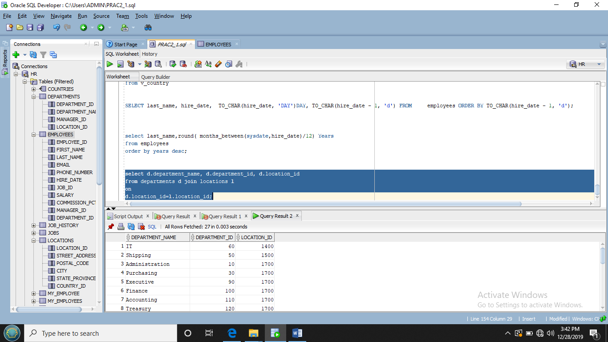

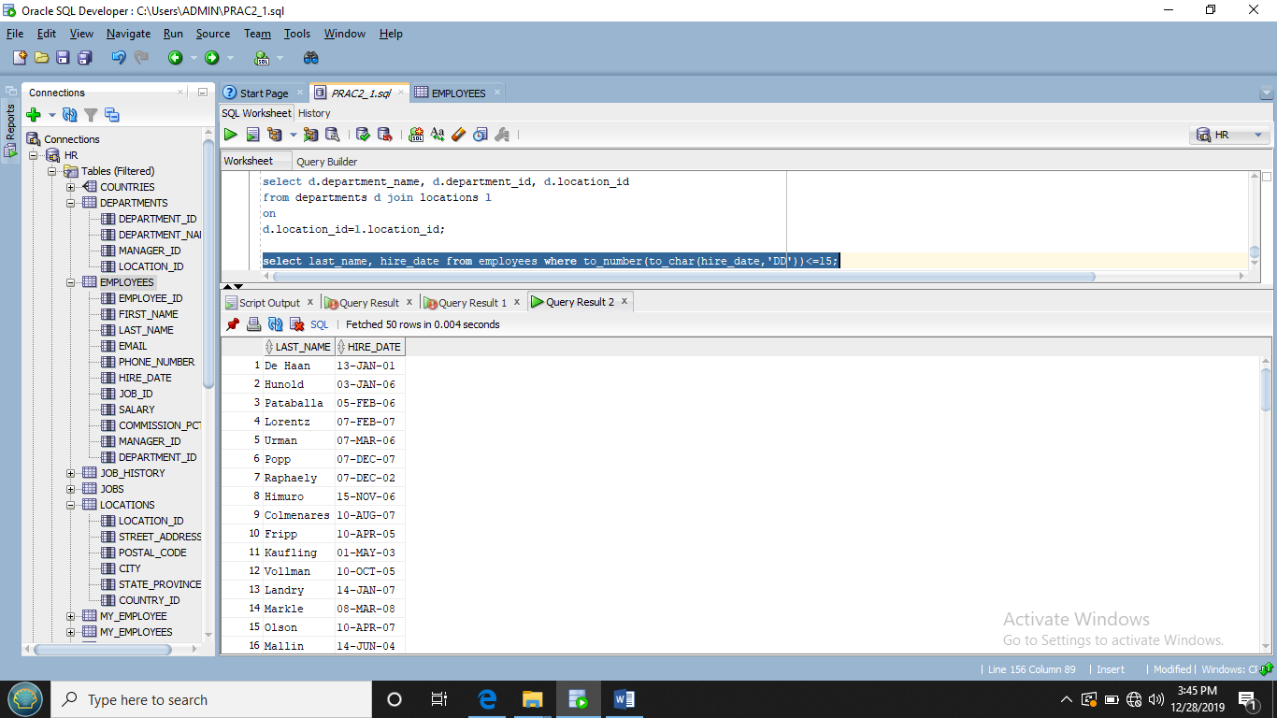

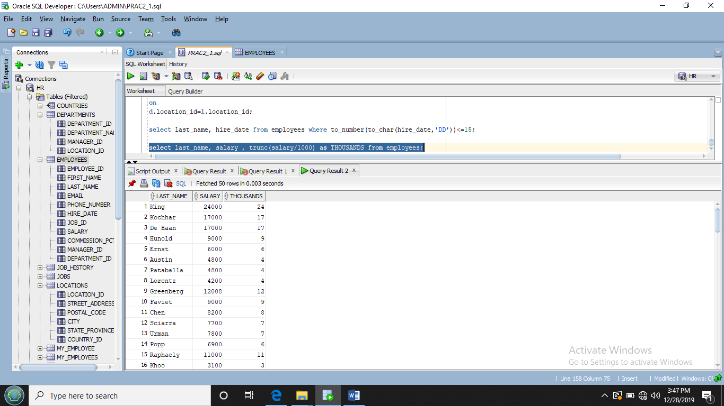

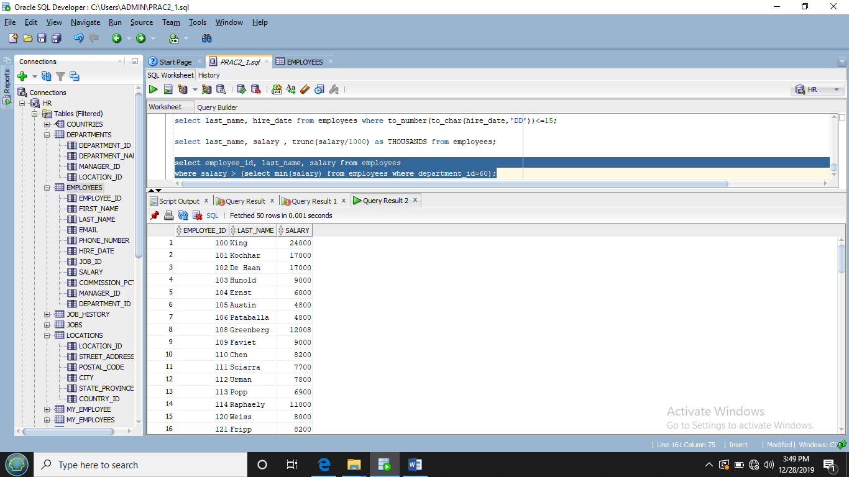

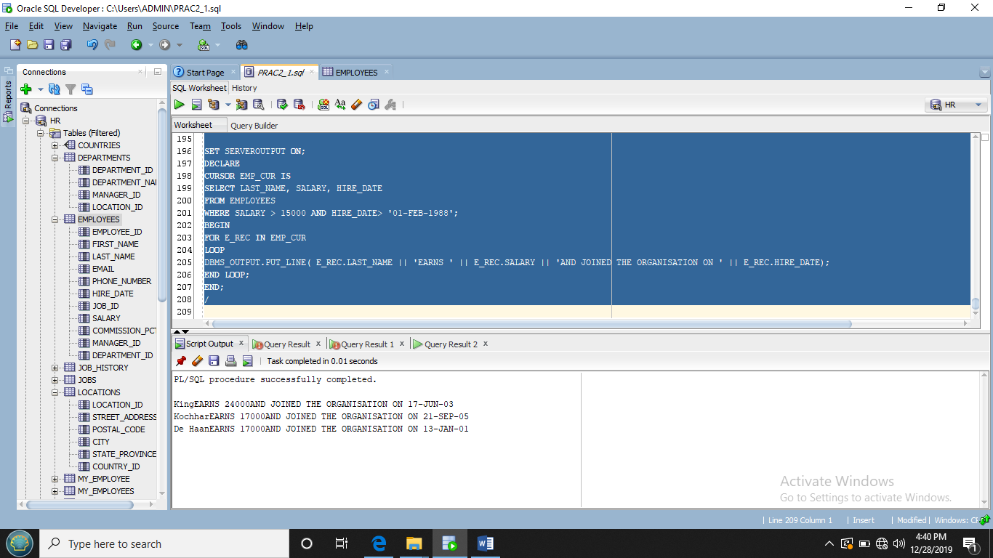

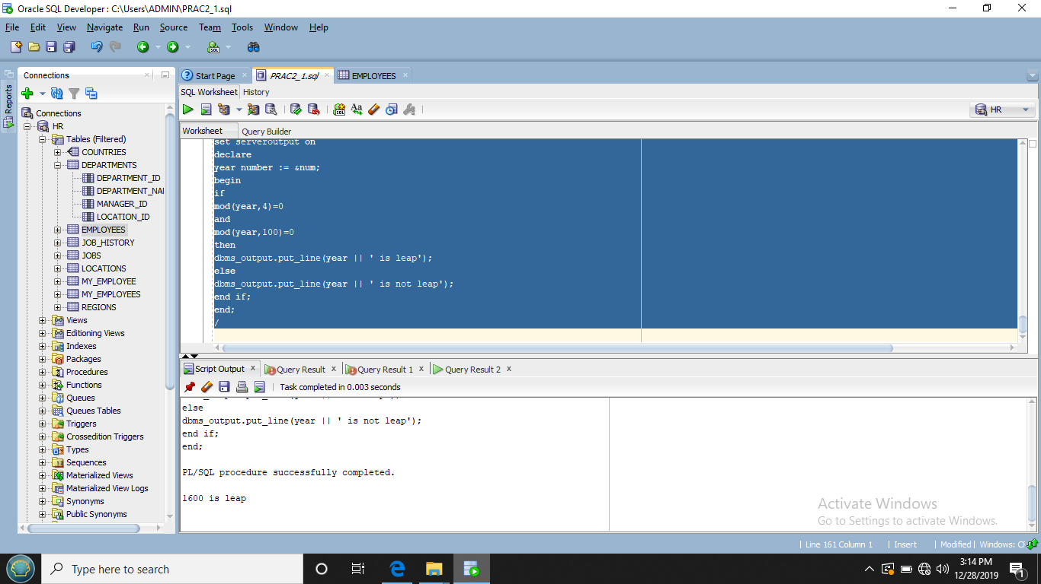

select last_name,round( months_between(sysdate,hire_date)/12) Years

mod(months_between(sysdate,hire_date)/12) as Months

from employees

order by years desc;

select d.department_name, d.department_id, d.location_id

from departments d join locations l

on

d.location_id=l.location_id;

select last_name, hire_date from employees where to_number(to_char(hire_date,'DD'))<=15;

select last_name, salary , trunc(salary/1000) as THOUSANDS from employees;

select employee_id, last_name, salary from employees

where salary > (select min(salary) from employees where department_id=60);

SET SERVEROUTPUT ON;

DECLARE

V_NUM NUMBER;

DEPTNO EMPLOYEE.DEPARTMENT_ID%TYPE;

BEGIN

DBMS_OUTPUT.PUT_LINE(' ENTER EMPLOYEE NUMBER ' || &DEPTNO);

SELECT COUNT(*)

INTO V_NUM

FROM EMPLOYEES

WHERE EMPLOYEES.DEPARTMENT_ID := DEPTNO;

DBMS_OUTPUT.PUT_LINE(V_NUM || ' EMPLOYEE(S) WORK FOR DEPARTMENT NUMBER ' || DEPTNO);

END;

/

SET SERVEROUTPUT ON

DECLARE

month_sal number;

begin

DBMS_OUTPUT.PUT_LINE(' enter salary ' || &month_sal);

if

month_sal >= 20000

then

DBMS_OUTPUT.PUT_LINE(' The Bonus is $2000');

else if

month_sal >=10000 and month_sal<= 19999

then

DBMS_OUTPUT.PUT_LINE(' The Bonus is $1500');

else

DBMS_OUTPUT.PUT_LINE(' The Bonus is $1000');

end if;

end;

/

SET SERVEROUTPUT ON;

DECLARE

CURSOR EMP_CUR IS

SELECT LAST_NAME, SALARY, HIRE_DATE

FROM EMPLOYEES

WHERE SALARY > 15000 AND HIRE_DATE> '01-FEB-1988';

BEGIN

FOR E_REC IN EMP_CUR

LOOP

DBMS_OUTPUT.PUT_LINE( E_REC.LAST_NAME || 'EARNS ' || E_REC.SALARY || 'AND JOINED THE ORGANISATION ON ' || E_REC.HIRE_DATE);

END LOOP;

END;

/

SET SERVEROUTPUT ON;

DECLARE

YEAR NUMBER := &NUM;

BEGIN

IF

MOD(YEAR,4)=0

AND

MOD(YEAR,100)=0

THEN

DBMS_OUTPUT.PUT_LINE( YEAR || ' IS A LEAP YEAR');

ELSE

DBMS_OUTPUT.PUT_LINE( YEAR || ' IS NOT A LEAP YEAR');

END IF;

END;

/

SET SERVEROUTPUT ON;

declare

e_due exception;

v_lname employee.last_name%type := %abc;

v_sal employee.salary%type;

v_hiredate employee.hire_date%type;

v_years number(2);

begin

select last_name, salary, hire_date into v_lname, v_sal, v_hiredate from employees

where last_name=v_lname;

v_years= months_between(sysdate,v_hiredate)/12;

if v_sal < 3500 and v_years >5

then

raise e_due;

else

dbms_output.put_line('not due for raise');

end if;

exception

when e_due then

begin

dbms_output.put_line('v_lname || ' due for raise');

end;

end;

/